The Siamese record industry 1903-1940
James Mitchell (Khon Kaen University)
After completing a doctoral thesis on the hybrid genre luk thung (Thai country song) in 2012 (see Mitchell 2015), I determined to expand my attention to analysis of other Thai music genres and the development of the Thai music industry. I soon encountered significant barriers, such as the paucity of Thai secondary texts on popular music and the near absence of historical records of companies and sales charts (of the Top 40 variety). Thai discography was practically an open field. Even Alan Kelly’s famous discography listed only the numbers of Siamese Gramophone Company records without the names of song titles or performers. If my musicological analysis of Thai music was to be adequately historically contextualized, I had to consider how discography could be incorporated into my methodology.

This article examines what I have termed the Early Period of gramophone recording in Siam/Thailand - from 1903 to 1940 (see Mitchell 2016a: 444), with a view to making a direct comparison between the recording industry of Siam and those of Indonesia (Dutch East Indies or DEI), Malaysia (Malay) and Singapore (IMS). Philip Yampolsky’s ‘The record industry in Indonesia/Malaysia/Singapore: the mechanics of an estimate of quantity 1903 -1942’ (2011) provides estimates of the number of records issued for the IMS region and details the history of the brands involved. Comparison with Siam is a significant step towards writing the combined discographical history of the Southeast Asian region.

Part I: Description of Brands
The Gramophone Company and His Master’s Voice
The first commercial 78s in Siam were recorded in 1903 by Fred Gaisberg (accompanied by a twenty year old George W. Dillnutt) for The Gramophone Company. Over the ensuing decade these single sided GC recordings were marketed as Thewada mi pik (‘winged angel’) or Arahan (‘holy man’) brand. Gaisberg gave these recordings matrix numbers with the prefix E. Renowned discographer Alan Kelly identified E750-780 (for 10 inch discs) and E2000-2065 (for 6 and 12 inch discs) as Siamese but was not able to transliterate or translate the songs or performers.

The Gramophone Company did not record again in Siam until 1909 when Dillnutt returned to Bangkok as the newly appointed GC Oriental expert. According to Michael Kinnear, Dillnutt arrived in Siam circa April 1909 (2000: 28-31), but GC correspondence from Indian Branch Manager James Muir, dated 1st April 1909, suggests that Dillnutt may have completed the recordings in March. These one hundred matrices - 10775o to 10874o - were issued as two different series in quick succession because the coupling was incorrect the first time. The second series, issued in 1912, had black labels, featuring the famous Nipper illustration. Consequently, for the purposes of this article, I have counted these as His Master’s Voice records.

Max Hampe, who relieved Dillnutt in November 1910, appears not to have recorded in Bangkok. According to Alan Kelly, Arthur Spottiswoode Clarke replaced Hampe as chief recording engineer in India in early 1914 and recorded 3448y to 3596y in Singapore (Yampolsky 2011: 185). Siamese HMV records prove that Spottiswoode Clarke also visited Siam in 1915 and recorded at least 186 sides (3635y-3821y).

No further Siamese recording took place until well after WWI. Yampolsky writes that Dillnutt recorded in Singapore in February1922 resulting in BK 248-325, and that he did not travel on to DEI (2011: 197). However, it can be added to the historical record that Dillnutt must have gone to Bangkok, because I have found BK352-BK568, which appeared on 35 known issues ranging from P6011 to P6169.

Robert Edward Beckett recorded in 1925 with numbers between BD3151 and BD3509. This range is highly significant because Kinnear and Kelly state that Bennett went from Calcutta to Rangoon to Singapore and then to Java. According to Yampolsky, Kinnear and Kelly have a gap between BD 3111 in Calcutta and BD 3490 in Singapore and that they assumed these recordings took place in Rangoon and Singapore (2011: 197). Since I have 36 confirmed numbers within this gap, it can be safely posited that Beckett visited and recorded in Siam between Rangoon and Singapore. Indeed, it may be that Beckett did not record in Rangoon at all. The possibility that he recorded Thai musicians in Burma is unlikely considering the range of material – Northern folk music or sor, phleng Thai doem and lae preaching.

In 1926 Douglas Ewen Larter recorded in Bangkok and Chiang Mai using the initials BL. Kinnear and Kelly suggest that the highest Bangkok matrix was BL2986 (Yampolsky 2011: 197), but since I have only found numbers between BL2516 to BL2643 this seems unlikely. The BX matrix prefix belonged to Arthur James Twine, who certainly recorded BX2150 to BX2267 in 1927 and BX6409 to BX6752 in 1930. Sandwiched in between was another Beckett expedition in July 1928, with known recordings ranged from BD6406 to BD6651. Kinnear and Kelly’s assertion that Beckett recorded BD6288-6583 may be inaccurate (Yampolsky 2011: 197). They also write that BD6594-6714 were Teochew music recorded in Bangkok and Singapore, but the records I have found above BD6594 are not Teochew music. Following Twine’s second expedition to Bangkok in 1930, it appears that HMV reissued selections from their back catalogue and ceded responsibility for recording in Siam to fellow EMI brand Odeon.

Yampolsky cautions that throughout the 1920s and early 1930s HMV Oriental records were issued as two omnibus series, P and N, which mixed countries up without evident assignment of numerical blocks (2011: 196). My estimate of HMV Siamese records takes this into account, nevertheless, the large sample of these records that I have catalogued indicate that some blocks can be assumed. For example, the existence of 32 issues within P6000-6100 strongly suggests that all the records in this range were Siamese. Similarly, 61 confirmed issues between P6800 and P6920 also denote a Siamese block. Thus, I calculate there were 900 HMV issues between 1910 and circa 1931.

Odeon
Siamese Odeon records were produced during two distinct periods – 1908 to 1914 and then from 1928 to the outbreak of WWII. Odeon opened a branch office in Calcutta in 1906 and from late 1906 stationed Alexandre Nagel, a recording engineer, there to make new Odeon recordings all over India, Southeast Asia, and Hong Kong (Yampolsky 2011: 183). Phunphit is uncertain how to date Odeon, suggesting a range of 1904 to 1908 for the first expedition but definitely before 1909 (1997: 82). Yampolsky believes that the 90000 and 91000 DEI blocks were recorded on two expeditions dated early 1907 and early 1908. This could indicate that the Siamese 76000 and 101000 blocks were also recorded in two expeditions from the same period. Yampolsky suggests that the DEI 112000, 114000, 115000 series probably originated from a recording expedition in 1911 or 1912. So perhaps the Siamese 150000 series also came from this last expedition before WWI. However, according to two Gramophone Company reports from George Dillnutt (13 January 1910 and 18 April 1910), Odeon recorded 350 records in Bangkok in late 1907 and 400 in March 1910. Since this amount (750) is greater than my estimated total for Odeon prior to WWI (590), it is likely that there were only two Odeon expeditions to Siam prior to WWI. Evidence for this and the dates can be found in the cover of an Odeon catalogue which reads “Dai at khuen mai, khrang thi 2, pi R.S.129” which translates ‘Newly recorded for the second time, the year 1911’.
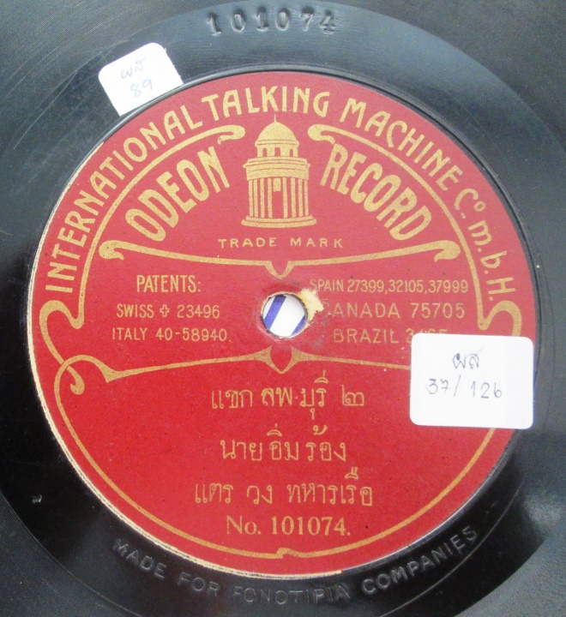
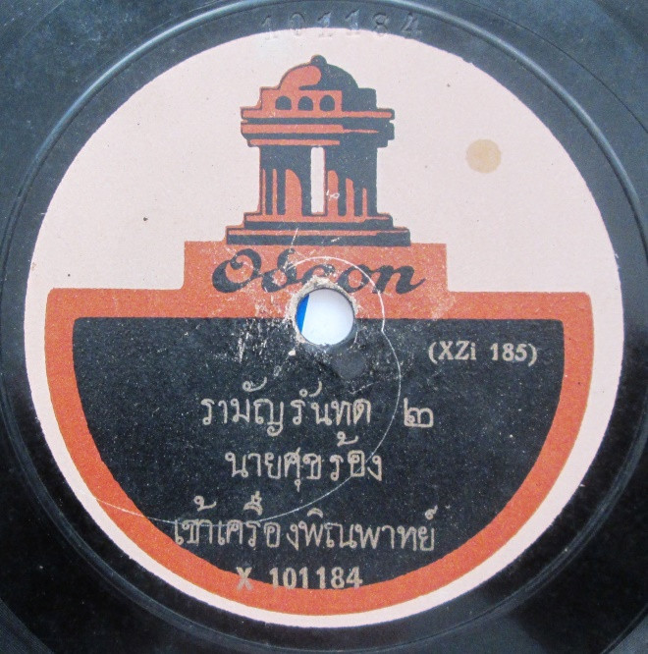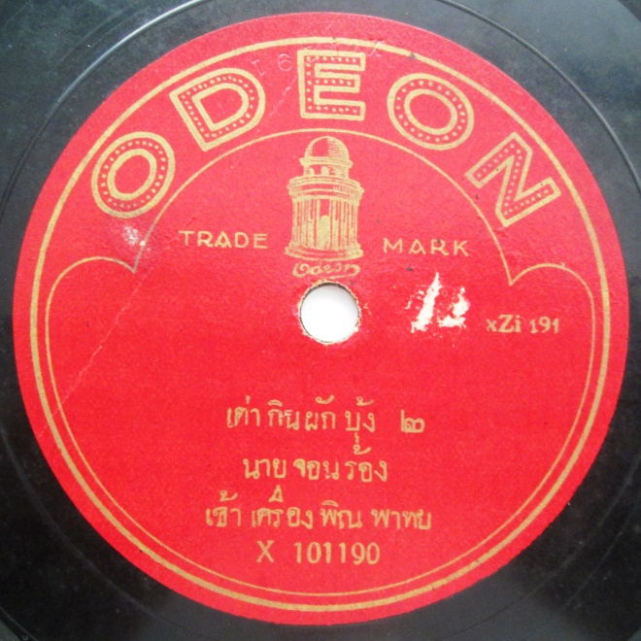
Figure 1. Examples of the Odeon 101000 series. Some early Odeon records are inscribed with ‘MADE FOR FONOTIPIA COMPANIES’. Fonotipia was founded in 1904 but was taken over by the International Talking Machine Co. in 1905. Christian Zwarg has informed me that the lower two are examples of post WWI reissues.
In 1928 Odeon returned to Siam to record the A229000 series for the Lakhon Tuek Tamban. According to Rainer Lotz, these records were being manufactured in Germany in September 1931 so further information is required to know the correct dates for this series. The OB5000 series extended from 1933 to 1940 and began with the first recording of the new Thai national anthem.

Columbia
Columbia Phonograph Company Gen’l was the only American company to record in Siam prior to WWII. Engineer Henry L. (Harry) Marker toured Asia throughout the second half of 1907 and devoted the 65100 block to Siamese recordings, although the existence of only two of these records can be confirmed. According to a GC report from S.H. Sheard (20/05/1908), Robinson Piano Co. paid for Columbia to take 35 recordings in October 1907. A further series extending from S70001-S70625 was completed circa 1930 in partnership with T. Ngekchuan, who issued some of these matrixes on Kratai. The engineers for this expedition may have been either American or British because in 1925 U.S. Columbia had been taken over by its British subsidiary, the Columbia Graphophone Company Ltd (Gronow 1981: 261-2).

Lyrophon
According to Sheard’s 1910 GC report (18/04), German company Lyrophon recorded 468 sides in Siam in December 1909. Lyrophon used the 80000 block in Siam and the first thirty or so records appear to have been marketed by Katz Brothers under the brand Siamese Concert Record (80001-80030), although the only real evidence for this is that both Katz and Siamese Concert Record bear the same gun symbol. 80057-80244 were issued on the Lyrophon brand, known in Siam as Tra Dork Lamphong (‘gramophone bell’). It appears that over 200 matrices were never issued.

Beka, Katz Brothers and Suea
The first Beka expedition to Asia in 1905-6 (which did not include Siam) is well documented, but very little is known about the second expedition, dated from December 1906 to June 1907 by Kinnear, but from June 1907 to February 1908 by Christian Zwarg (see Yampolsky 2011: 181-2). Yampolsky has determined that at least the first fifty Siamese matrices were issued on the Beka-Grand label before mid-1909, but my recent research at the EMI Archives in London makes a more accurate estimate possible. A GC report from S.H. Sheard from 1908 (20/05) indicates that the first Siamese Beka records went on sale in Bangkok circa August 1908 and, therefore, were recorded circa January 1908. This is compatible with Zwarg’s dates for the second expedition. A second GC report from S.H. Sheard from 1910 (18/04) mentions that Beka had recently taken 500 Siamese matrices, which were to be offered as 250 new double sided records circa June 1910 (and thus probably recorded about November 1909). These dates and the amount of recordings taken would appear to preclude Yampolsky’s suggestion that there may have been an additional expedition prior to mid-1909. 25001 to 25056 were issued on the deep maroon Beka Grand Record label. From at least 25072 to 25342 Beka matrixes were labelled as Katz Brothers Ltd, known in Thai as Tra Chang Phueak (white elephant) because the first batch has a white elephant against a bright red background and were marketed in Siam by Khi Chiang and Sons (see figure). From 25125 up to 25342 Katz Brothers records are purple with a distinctive drawing of an automatic pistol (possibly a Mauser) (see figure). Suea (tiger) is an early Siamese brand that features a beautifully drawn tiger but no writing to identify the brand or company. However, the record numbers – 25382 up to 25458 – show that Suea was actually the next Beka brand after Katz Brothers. The gap between highest known Suea (25458) and lowest known new 25000 block Parlophon recording (25639) suggests that some of the 500 Beka matrices taken in late 1909 were never issued and probably lost.
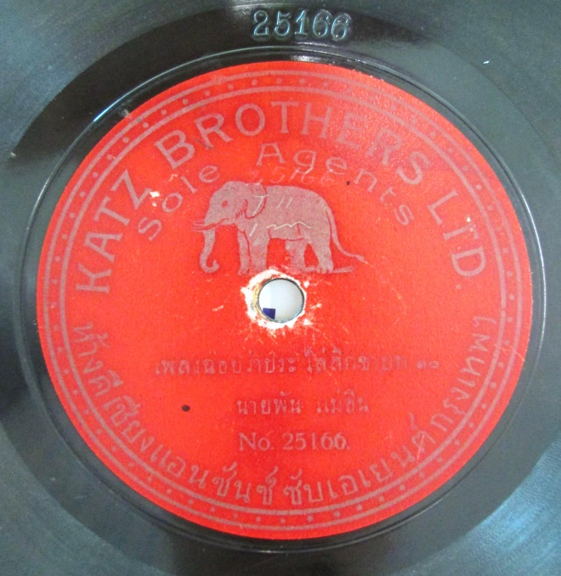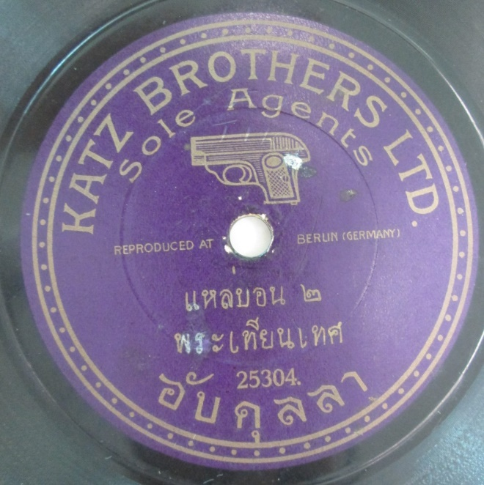
Figures 2 and 3. Katz Brothers 25166, Tra Chang Phueak (white elephant), and 25304.

Favorite
The Bangkok trading company Windsor and Co. organized the expedition of German company Favorite to record in Siam in March 1910. The o matrix prefix identifies Max Birkhahn as the engineer. My estimate from those records I have encountered is that around 300 sides were issued, although Sheard’s GC report, dated 18/04/1910, suggests that 400 songs were taken. These records were marketed as Phaen Siang Samrap Phumi Bandasak (‘records for the nobility’), but the brand was also known as ‘Ramsun (thunder giant) and Mekhala’ (goddess of lightning) in description of the beautiful label.
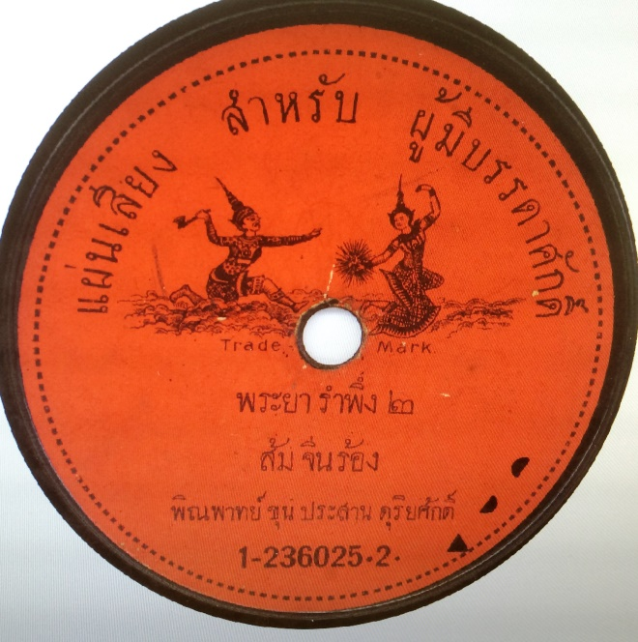
Figure 4. Phaen Siang Samrap Phumi Bandasak.

Pathé
Pathé was the only brand of Siamese records that played from the centre to the edge and thus required a unique player. As researched by Christian Zwarg, the Pathé numbering system was also unique, with what appears to be the matrix number actually being a manufacturing code assigned as the master cylinders were processed at the factory (see Zwarg ). This has meant that dating of Pathé records has been extremely problematic. Perhaps that is one reason why there is some confusion among Thai sources as to when the first Pathé recording expedition took place. Pluethiphol suggests that Pathé first recorded in Siam at Wang Ban Mor (the palace of Prince Phithak Thewet) between 1902 and 1907. Sansani (2011 : 44) claims that Phunphit Amatayakun (but without text name or page number) has evidence that Berliner recorded in Siam in 1903 at Wang Ban Mor, but I have never seen any of these discs so perhaps he means Pathé. Sansani suggests that Pathé first recorded in Siam in 1910 (2011 :45).

But because I have located a large sample of the Siamese records and catalogued their manufacturing codes, Zwarg’s statistical method makes it possible to date their arrival at the factory to the month. The Siamese manufacturing codes form two clear groups: 48749 – 49318 and 60400 – 61524. These groups can thus be dated to November 1909 and September 1910. But how long would it have taken for the master cylinder to reach Belgium from Bangkok? According to a Gramophone Company report from George Dillnutt (18 April 1910), Pathé issued 344 new records in January 1910, meaning that two months should be allowed for freighting. If we assume that Dillnutt actually meant 344 sides, rather than records, then my pre-WWI estimate of 625 sides appears to suggest only two expeditions took place. These two Siamese expeditions can, thus, be dated to circa August 1909 and June 1910.

There is, however, a second Siamese series (47601-33), which must have been issued after 1915 since they have paper labels bearing a red rooster (see Gronow 1981: 263). By this time Pathé had changed their recording system and the records were no longer given manufacturing codes. It is theoretically possible that this series could represent a third expedition immediately prior to WWI. That the records were not electrically recorded means they must be dated prior to 1928. In the absence of other clues, the best way to date the records approximately is via the names of the performers. Nang (Mrs) Lek Suksot recorded for HMV in 1925, 1926 and 1930, Odeon in 1928 and Parlophon in 1927. This implies that this third Pathé expedition took place in the period 1925-1927.

Kratai
Kratai was founded by Sino-Thai businessman T. Ngekchuan (1889-1970). T. Ngekchuan first recorded in 1925 with Parlophon engineers, who had been booked by a Thai store named Hang Suthadilok for a recording session of the Krom Mahorasop (department of entertainment). Further Kratai recording sessions took place in 1928, 1930, 1931, 1935, 1937, 1938, 1939 and 1940. T. Ngekchuan used the services of whichever company was available, whether Parlophon, Polyphon, Deutsche Crystalate, Carl Lindström, Odeon, Columbia or HMV. Consequently, Kratai matrix prefixes from before WWII, include CSJ (Deutsche Crystalate), ZS and A (Odeon), RS, S, C and CT (Columbia), and OJE (HMV). T. Ngekchuan also produced a short run of records with silver labels for Prince Phanuphon Yukhon in 1938 under the brand Phaphayon Thai (Thai Film).

Parlophon
Following WWI Lindström returned to the Siamese market and began by reissuing the entire Beka Grand Record, Katz Brothers and Suea back catalogues as a mauve Parlophon series extending from 1 to 128, in which the same issue number was used for extended compositions spread over multiple discs. Some of the 1-128 series are marked 1925, which is probably when they were issued. These new recordings appear to be from around 25639 up to 25912 and were issued as 205-273 (maroon), some of which are marked 1927, and B18001 to B18199 (maroon). The Lyraphon back catalogue, which used the 80000 block, was reissued as 500-559. Next, Parlophon reissued the thirty sets of recordings in the Siamese Favorite (Phaen Siang Samrap Phumi Bandasak) back catalogue as B18224 to B18253 (mauve). Then a new 82000 block was begun and records were issued as B18500 to 18589 (dark maroon), B18701 to 18761 (green), and finally as B18802 to 18808 and B18900 to 18903 (dark blue). A few Parlophon recordings were issued on six inch Lindex discs.

Deutsche Crystalate
Deutsche Crystalate G.M.B.H. recorded and manufactured records for four Siamese brands: Khana Nari Srisumit with issue numbers 30000 to 30009 (CSJ2934-2953), Phaen Siang Sayam 30120 to 30254 (CSJ2513-2994), Rakhang Thorng/Golden Bell 30406 to 30472 (CSJ2555-3034) and Kratai 30601 to 30652 (CSJ2594-3043). Khana Nari Srisumit was also known in Thai as Kropphak Si Thong (golden head dress), while Phaen Siang Sayam was referred to as Tra Chang Samsian, because of the label illustration of the three headed elephant god.

As with Pathe, Thai sources disagree on the dating of Deutsche Crystalate’s expedition(s). Phunphit mentions that this series was recorded at T. Ngekchuan’s shop in 1929, but according to Mahidol Library the records were not issued until 1933. These four Deutsche Crystalate series have a combined estimated total of 586 sides, and it appears that the range of CSJ matrix numbers (with S standing for Siam) must have extended from 2501 up to around 3100. Zwarg has discovered that German DC series stop at 2500 and then skip up to 3988 (p/c Zwarg 24/072016), a gap that accommodates both the Siamese and Chinese DC series. Du Jun Min dates the 800 known Chinese DC sides all to 1932 (2011: 34), while Zwarg attests that a Chinese opera singer’s record with numbers 3241 and 3242 was recorded on January 1932 (p/c Zwarg 24/072016). Thus, it is most likely that the approximately 600 Siamese DC sides were obtained during one expedition in mid-1931.

Polyphon and Serani
Polyphon appears to have only made one visit to Siam, recording for the brand Serani (named after the singer Khun Ying Serani. A small number of records were also released under the Polyphon brand but with the inscription: ‘Nai T. Ngekchuan at phiset’ – ‘special recording for Mr T. Ngekchuan’. Starting with Serani and continuing to Polyphon, the known range is 2397BD to 2665BD (around 270 sides). Both brands are stamped with ‘Mechan Copt 1930’, which is a copyright notice that means they were manufactured in 1930 (in Germany). From these matrices, Christian Zwarg is able to identify the engineer as Oskar Blaesche. Furthermore, Zwarg knows that 2666 was recorded in Berlin in July/August of 1930 and was issued on 1st September. He also knows that 2036 was recorded in Oct 1929 in Munich. It appears that Polyphon recorded in Singapore before Siam (see Yampolsky 2011: 210). This all suggests that the Siamese recording session took place during the period April to June 1930.

Other Brands
Ling (‘monkey’) was manufactured by Carl Lindström AG from 1937 to 1941 in India on behalf of Hang Tek Huat. The ZM matrix code suggests that this brand was recorded by Odeon engineers with M presumably standing for ‘Monkey’. Bua (see figure) was the brand of Khana Lakhon Pridalai, which also recorded on Odeon in 1936. Thep Duriyang was the brand of Hang Phaen Siang At Tangkhanikhro, which competed with Kratai for a short time prior to WWII. The film company Srikrung began issuing records in 1936, in order to promote their films through gramophones in private homes, radio stations and cinemas.
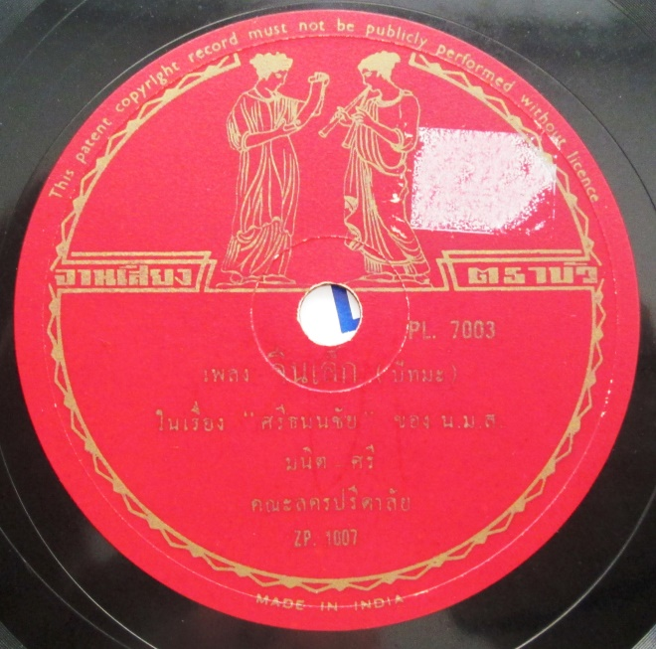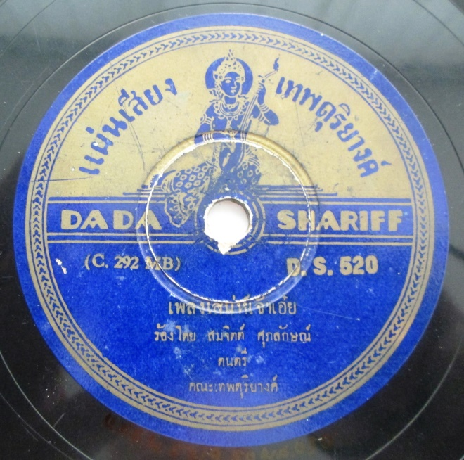
Figures 5 and 6. Bua and Thep Duriyang.

Part II: Table of Siamese/Thai Record Brands 1903-1940
The table below lists the brands active in Siam from 1903 to 1940. In order to facilitate direct comparison with IMS I follow the same methodology as Yampolsky (2011). I count issue numbers rather than matrix numbers because not all matrix numbers were actually marketed. For the estimate I use the LK (lowest known number) and HK (highest known number) as a guide, bearing in mind that the LK may indicate an even lower number and that matrix series were usually filled up in blocks (see Yampolsky 2011: 181). However, the change from single sided records to double sided must be taken into account. An additional complicating factor is that some brands, such as The Gramophone Company, used separate issue numbers for each record of a series, whereas others, such as Pathé, issued multiple records (as many as 23) under the one issue number. Thus, in order to compare accurately with Yampolsky (2011), an estimate of the number of sides is also provided. This is accomplished by dividing the known number of sides by the known number of issues and then multiplying by the estimated number of issues. For example, I have catalogued 12 Phaen Siang Samrap Phumi Bandasak / Favorite issues and know that these records had 113 sides. From the known issue numbers, an overall total of 30 Favorite issues can be reliably estimated. Thus the estimated number of sides is 113 divided by 12 multiplied by 30 = 303 sides. Of course, these estimates are a work-in-progress, and any additions or corrections will be most welcome and will be incorporated into the final publication of the Thai 78 rpm Discography.

Brand | (1903- 1915) | (1920-1940) | Series prefix and known range | Matrix prefix and known range | KnownRecords | Known sides | Estimated total of issues | Estimated total of sides
Beka |  |  |  | 25001-56 | 18 | 18 | 56 | 56
Bua |  |  | PL7003-4 | ZP (1004-7 & 7010) | 2 | 4 | 10 | 20
Columbia (US) |  |  |  | S (65119- S65140) | 2 | 2 | 35 | 35
Columbia (green) |  |  | 51002-107 | S (700018-625) | 17 | 78 | 110 | 550
Gramophone / Arahan |  |  |  | E (750-80)  E (2000-65)  o (10775-874) | 201 | 201 | 201 | 201
His Master's Voice Siamese |  |  | GC7-12175–GC7-19325  GC8-14650– GC13-12122  P6011-169  P6801-920  P7791-8676  P9095-197  P16502-86  P16601-792 | o (10775-874)  y (3635-3821)  BK (352-568)  BD (3151-3509)  BL (2516-2643)  BX (2150-2267)  BD (6406-6651)  BX (6409-6752) | 487 (276) (211) | 698 (276) (422) | 900 (240) (660) | 1560 (240) (1320)
Katz Brothers Ltd. |  |  |  | 25072- 342 | 98 | 98 | 250 | 250
Khana Nari Srisumit |  |  | 30000-30009 | CSJ (2934-2953) | 5 | 10 | 9 | 18
Kratai / T. Ngekchuan |  |  | 30601-52  K3001-12  RB201-203  TNC301-8  HA6001-75  HA6201-3  T201-206  T7001-7156  TNC901-25  N123-124  C1001-31  U2001-20 | CSJ (2594-3043)  CSJ (2831-34), S (700271 & 622)  RS (9040-82)  ZS (165-240)  ZS (119-246), RS (9049-85)  ZS (897?)  TNC (reissue)  A (5128-6507), C (37-365), CT (602-639 & 1003-1014), OJE (1707-08)  C (41-368), CT (610), A (5130-6463)  C (90-93)  A (5173-5218 & 6376-6429), C (272-331)  C (1-75), MSK (reissue) | 264 | 564 | 400 | 856
Lindex |  |  | 222-229 | 25986-7 | 1 | 2 | 10 | 20
Ling |  |  | Mo9001-68 | ZM (3009-148) | 55 | 110 | 68 | 136
Lyrophon Concert Record |  |  |  | 80047-244 | 60 | 60 | 190 | 190
Odeon |  |  | 76600-7  101014-556  X150000-37  A229000-42  OB5001- 137  ARB1-8 | xZi (89-657)  xZi (43-368)  ZB91-490  ZB501, OMT4-6  ZB716- 81 | 378 (205) (173) | 741 (205) (536) | 776 (595) (181) | 1191 (595) (596)
Parlophon |  |  | 8-128  205- 74  500-559  B18001-204  B18225  B18500-89  B18703-61  B18802  B18900 | B (25029-394)  25678- 913  80001-244  25005-935  1-236002–030  82034-777  82010-823  82920-57, 147052-3  82270-83 | 209 | 1115 | 503 | 2370
Parlophone |  |  | HA6001-27 | ZS (122-220) | 6 | 12 | 20 | 40
Pathé |  |  | 47004- 48  47052-106 | GR (48749-49329 & 54144)  GR & RA (60157-61524 & 67201) | 72 (59) (13) | 370 (328) (42) | 140 (100) (40) | 759 (625) (134)
Phaen Siang Samrap Phumi Bandasak / Favorite |  |  | 1-236002–030 | o (8566-634) | 12 | 113 | 30 | 303
Phaen Siang Sayam |  |  | 30120-30254 | CSJ (2513-2994) | 27 | 54 | 160 | 320
Phaphayon Thai |  |  | VS101-2 & TP1001 | A (5451-2) | 3 | 6 | 10 | 20
Polyphon |  |  | V3554-649 | BD (2633-65) | 8 | 16 | 20 | 40
Rakhang Thorng |  |  | 30406-30472 | CSJ (2555-3034) | 23 | 46 | 72 | 144
Serani |  |  | V3318- 529 | BD (2397-590) | 34 | 68 | 115 | 230
Siam Concert Record |  |  |  | 80001-30 | 30 | 30 | 30 | 30
Srikrung |  |  | SK8001-44 | ZB (548-653), ZI (2005-73) | 33 | 66 | 50 | 100
Suea |  |  |  | 25377-458 | 19 | 19 | 81 | 81
Thep Duriyang |  |  | DS501-20  RL703 | A (6353-484), C (221-91) | 8 | 16 | 25 | 50
 | 983  (Total 1903- 1915) | 1092  (Total 1920-1940) |  |  | 2076  (Total 1902-1940) | 4521 (1354) (3167)  Known sides | 4271 (1808) (2463)  Estimated issues | 9570 (2616) (6954)  Estimated sides

Table 1. Siamese/Thai Record Brands 1903-1940 – known records and estimated totals.

Part III: The Siamese record industry in regional perspective
The populations of the two regions circa 1910 were 8.3 million in Siam and 42.8 million in SIM, a ratio of 1:5. Circa 1935 the populations were 11.5 million for Siam and 65 million for SIM (Hirschman and Bonaparte 2012: 8), a ratio of almost 1:6. Also, circa 1910 Siam had one city, Bangkok, with a population of more than 100,000 whereas SIM had five: George Town, Singapore, Batavia, Surakarta and Surabaya. Although Bangkok was easily the largest of these six cities, around a third of its population was Chinese (Porphant 1997: 244), who would not have consumed Siamese records. Despite the very significant Chinese and Indian populations in Bangkok, the SIM region had a much broader spread of ethnicities to be serviced by recordings than Siam. These statistics suggest that SIM should have had a recording industry at least five times the size of Siam. But this was not the case, at least in terms of issues.
City | Population circa 1910
Bangkok | 365,000
George Town | 101,000
Singapore | 295,000
Batavia | 140,000
Surakarta | 125,000
Surabaya | 152,000
Table 2. Populations of largest cities in Siam and SIM circa 1910.
 | Siam (Thailand) | DEI (Indonesia) | Malay/Singapore | DEI+M/S (SIM)
1903-1917 | 2616 | 5508 | 2106 | 7614
1920-1942 | 6954 | 12943 | 7248 | 20191
Total (1903-1942) | 9570 | 18451 | 9354 | 27805
Table 3. Estimated record production (number of sides) of Siam, DEI and Malay/Singapore.

In terms of sides, the grand total for 1903 to 1942 for Siam/Thailand is 9,570 versus 27,805 for SIM, a ratio of 1:2.9. This ratio remains constant when the total is broken down into the two periods interrupted by the First World War: between 1902 and 1917 Siam’s total is 2,616 versus SIM’s 7,614 (1:2.9); between 1920 and 1942 Siam’s total is 6,954 versus SIM’s 20,191 (1:2.9). The size and demographics of the Siamese record industry in relation to the SIM record industries will be analyzed in a forthcoming article. It is certainly fascinating to see how outsized the recording market in Malaysia/Singapore was compared to that of Indonesia, or as it was then known, the Dutch East Indies. The combined population of Malaysia/ Singapore circa 1910 was only 2.6 million vs 40.1 million for DEI. Circa 1935 it was 4.4 million vs 60.7 million. Thus Malaysia and Singapore accounted for only six percent of the SIM population in 1910, increasing to 6.75 percent circa 1935 (Hirschman and Bonaparte 2012: 8). However, the record industry in Malaysia/Singapore was 28 percent of the SIM total for the period 1903 to 1917 and then an amazing 36 percent during 1920 to 1942. The demographics of Siam’s record industry and economy during the period 1903 to 1942 must presumably lie in between those of Malaysia/Singapore and the Dutch East Indies.

Conclusion
Prior to the First World War there was considerable competition between companies from the western colonial powers of Britain, France, Germany and USA to achieve market share in the emerging Siamese record industry. After WWI, the industry was slow to resume and by 1931 the international participants had been reduced to EMI, Polyphon and Deutsche Crystalate. However, after 1925 indigenous Siamese brands such as Kratai, Serani, Ling and Thep Duriyang gradually began to assume more importance. Throughout the period 1903-1940, the population of Siam compared to that of SIM was between 1:5 and 1:6. Yet the Siamese record industry compared to that of SIM, at least in terms of quantity of releases, was steadily just under 1:3.

The method, whereby I have collected discographical data from a multitude of sources and organized them into an analyzable format, has shown immediate results. Through close comparison with Yampolsky, I have been able to prove that Spottiswoode Clarke recorded in Siam in 1914, Dillnutt in 1922 and Beckett in 1925, all previously unknown expeditions. Comparison of record production figures with historical population data reveals that Siam’s record industry was surprisingly large. The reasons for this will require a separate article. However, I expect that the full value of this method will be seen once similar research is conducted across other Asian nations.

The discographical research contained in this article is a necessary part of writing the history of Thai music, and by extension, the history of Southeast Asia. Combining this research with Yampolsky (2011) is the first stage in preparing a history of Southeast Asian music that looks beyond national borders; a history that views music in the context of industrial developments and colonial and semi-colonial relationships.

References
Chandvankar, Suresh 2010 ‘Odeon labels in India’ in The Record News: The journal of the ‘Society of Indian Record Collectors’, Mumbai
Du Jun Min 2011 ‘Lindström in China’, in P Gronow & C Hofer (eds), The Lindström project: contributions to the history of the record industry. 3, Gesellschaft für Historische Tonträger, Vienna, 2011, 12-47
Gronow, Pekka 1981 ‘The Record Industry Comes to the Orient’, Ethnomusicology, 25(2) (May, 1981), 251-284
Gronow, Pekka 1983 ‘The Record Industry: The Growth of a Mass Medium’, Popular Music, v3, 53-75
Handley, Paul M. 2006 The King Never Smiles: A Biography of Thailand’s Bhumibol Adulyadej. New Haven and London: Yale University Press
Hirschman, Charles and Bonaparte, Sabrina 2012 ‘Population and society in Southeast Asia: A historical perspective’ in Ed Williams, Lindy & Guest, Philip, Demographic change in Southeast Asia: Recent histories and future directions. Ithaca, NY Southeast Asia Program Publications, Cornell University, 5-41
Kelly, Alan [with details of Asian matrixes contributed by Michael Kinnear]. “Gramophone Company Matrix Series.” [MS Word files on CDs available from Alan Kelly at akark@dsl.pipex.com]
Kinnear, Michael 1994 The Gramophone Company’s first Indian recordings, 1899– 1908. Bombay: Popular Prakashan
Kinnear, Michael 2000 The Gramophone Company’s Indian recordings, 1908 to 1910: a complete numerical catalogue, by matrix serials, of Indian gramophone recordings made from 1908 to 1910, by The Gramophone Company, Ltd., in India. Heidelberg, Victoria, Australia: Bajakhana
Mattani Rutnin 1996 Dance, Drama, and Theatre in Thailand: The Process of Modernization. Chiang Mai, Thailand: Silkworm Books
Mitchell, James 2015 Luk thung: The culture and politics of Thailand’s most popular music, Chiang Mai: Silkworm Books
Mitchell, James 2016a ‘78s and the ‘golden age of Thai song’: Content and analysis of the Thai 78 rpm Discographical Framework’, SOJOURN: Journal of Social Issues in Southeast Asia 31(2) July 2016, 413-462
Mitchell, James 2016b ‘The Rabbit Record brand of Siam/Thailand 1925-1970: Assessing the Legacy of T. Ngekchuan’, Asian Music 47(2) July 2016, 48-83
Morton, David. The Traditional Music of Thailand, Berkeley: University of California Press, 1976
Phunphit Amatayakun 1997 Lamnam haeng Sayam: Ngan khon khwa rueang dontri jak phaen siang kao [Songs of Siam: A study of music from old records], Bangkok: Samnak Phim Nitayasan Hi-Fi Stereo
Porphant Ouyyanont 1997 ‘Bangkok's Population and the Ministry of the Capital in Early 20th Century Thai History’ Southeast Asian Studies, 35(2), September 1997, 240-260
Sansani Jasuwan 2011 Kan ban thuek siang phleng Thai: Korani sueksa phaen siang rong klap thang (‘Recording of Thai song: The case study of reverse direction records’). Ph.D. Diss., Suan Sunandha Rajaphat University, Bangkok
Stowe, Judith 1991. Siam Becomes Thailand: A Story of Intrigue. United Kingdom: C. Hurst & Co
Strötbaum, Hugo. Recording pioneers website, www.recordingpioneers.com. Accessed 12/10/2015
Strötbaum, Hugo 2008 ‘Favorite revisited: An update.’ 9. Diskografentag. Utrecht May 2008
Tan Sooi Beng. “The 78 RPM Record Industry in Malaya Prior to World War II” Asian Music 28(1) (1996/97), 1-43

Unattributed ‘Author Note Phra Sucharit Suda’. Mahidol University Library and Knowledge Center http://mulinet3.li.mahidol.ac.th/elib/cgi-bin/opacexe.exe?op=dig&db=MUSIC&pat=code&cat=aut&skin=u&lpp=16&catop=&scid=zzz&ref=A:@843&nx=1&lang=0. Accessed 06/06/2016

Wright, Arnold 1908 Twentieth century impressions of Siam: its history, people, commerce, industries, and resources, with which is incorporated an abridged edition of Twentieth century impressions of British Malaya. London: Lloyd's Greater Britain Pub. Co. Viewed at http://seasiavisions.library.cornell.edu/catalog/seapage:363_257. Accessed 14/1/2016
Yampolsky, Philip 2011 “The record industry in Indonesia/Malaysia/Singapore: the mechanics of an estimate of quantity, 1903-1942”, in P Gronow & C Hofer (eds), The Lindström project: contributions to the history of the record industry. 3, Gesellschaft für Historische Tonträger, Vienna
Yampolsky, Philip 2013 Music and media in the Dutch East Indies: Gramophone records and radio in the late colonial era, 1903-1942, Ph.D. Diss., University of Washington, Seattle

See http://www.charm.rhul.ac.uk/.
Prime Minister Phibunsongkhram first changed the country's name from Siam to Thailand on June the 24th (1939), as part of an overall strategy to weaken the monarchy’s hold on Thai society. Thus, in this article, when discussing the Early Period of recording, I refer to Thailand as Siam unless I am specifically discussing events that occurred after the name change.
The abbreviation IMS stands for the modern nations of Indonesia, Malaysia, and Singapore; or, in colonial times, the Dutch East Indies, Malaya, and Straits Settlements.
See http://www.charm.rhul.ac.uk/discography/search/page(1);jsessionid=553463B4F9A7AD83C50453C614CC908D.balancer5.
Expert was the industry term for recording engineers like Gaisberg. See Yampolsky (2013: 71).
Because I have often worked from photographs, the engineer matrix numbers are not always legible.
For a comparison with India see Chandvankar ‘Odeon labels in India’ (2010).
See http://www.lotz-verlag.de/lindstroem-mx-masterfile.htm.
See http://www.recordingpioneers.com/RP_MARKER1.html.
See Yampolsky 2011: 182. An article by Max Chop published on 30 June 1909 analyses recordings numbered 25017, 25020, 25032 and 25049. Unfortunately the names of the songs and performers are not given because Chop could not read Thai.
This date agrees with Hugo Strötbaum’s table in ‘Favorite revisited’ (2008: 15).
Solitary isolated numbers such as 54133 or 67201 can be ignored because occasionally a track had to be reprocessed
Earlier matrices were also reissued using this paper label.
See Mitchell (2016a) for a detailed history and analysis of Kratai.
A 1910 Gramophone Company report (18 April 1910), suggests that 400 sides were recorded but this does not mean that all sides were released.
The estimated total of Odeon needs to be reduced by a small amount because I have found a few instances in the pre WWI records where issue numbers were skipped. For example, “Tao kin phak bung” (‘tortoise eats vegetable’) sides one and two are actually numbered 101187 and 101190. It appears that 101188 and 101189 were omitted.
As explained earlier, for Pathé, these numbers are serial codes, which record the order of manufacturing, rather than matrix numbers, which record the order of recording.
This figure of 42.8 million for SIM found in Hirschman and Bonaparte 2012: 8 is consistent with the 40 million for DEI (not including Malay / Singapore) cited in a Gramophone Company report on the Dutch East Indies dated 24 October 1912.
According to http://www.populstat.info/Asia/thailant.htm, the population of Bangkok in 1910 was circa 600,000 but Porphant (1997) believes this figure was greatly inflated and thinks 360,000 is a better estimate.
According to http://www.populstat.info/Asia/malaysit.htm, the population of George Town in 1910 was 101,000.
According to http://www.populstat.info/Asia/singapoc.htm, the population of Singapore in 1910 was 295,000.
According to the 1912 Gramophone Company report (24 October 1912), the population of Batavia was 140,000.
According to http://www.populstat.info/Asia/indonest.htm, the population of Surakarta in 1910 was circa 125,000.
According to the 1912 Gramophone Company report (24 October 1912), the population of Surabaya was 152,000. This is confirmed by http://www.populstat.info/Asia/indonest.htm.
See Porphant (1997: 243).

